CPLA GUIDE

Please update the document when you have more tips
Date | Version | Author | Change Note
17/10/2012 | 0.1 | Jason Chou | Initial Version

Index

1. CPLA web sever 3
2. Where is CPLA GUI 4

CPLA WEB server
CPLA server URL: http://hzltecpserver02/
Click this you can access the CPLA server web, and then select parameter by hitting checkboxes as below;

“[/s:<all|uec|rrom>]” is optional. It specifies which C-Plane component need to be checked. In case of absent, the default value is “/s:all”.
“[/l:<all|ue|cell>]” is optional. It specifies the target level to be checked. In case of absent, the default value is “/l:all”.

Upload your log(.zip) by clicking on button and wait for some minutes…
Summary.html is the default web page while parsing successfully as below;
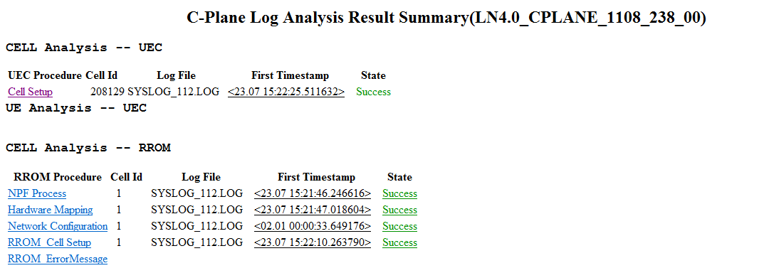

Where is CPLA GUI
On CPLA web server, you can find out the link and download cpla.zip in below bold rectangle.
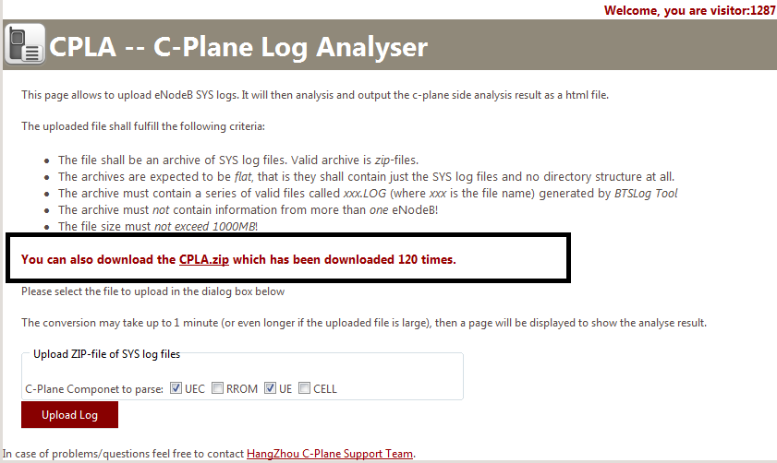

Run cplagui.exe, and then select your log file by clicking on browse button or input your path into textbox directly;
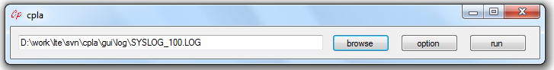
Sometimes you need to input parse parameter by clicking on option button;
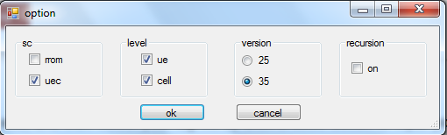
“version” is mandatory. “25” means RL25, and so on;
“recursion” is optinal.It means that if your subfolder files to be parsed or not.
Finally click on button “run” to parse .LOG files…
If parse successfully, file Summary.html will be opened by IE automatically; furthermore you can open the link in the Summary.html to find out related info or open the .html by the path .\ CPLAOutput\ directly.

